|  |  |
| --- | --- |
|  | 1. **To study Linux commands for process management tasks and file permissions** |

|  |  |  |  |
| --- | --- | --- | --- |
| **Name of Student** | **Hardik Prajapati** | **Roll No.** | **9152** |
| **Sign here to indicate that you have read all relevant material provided /available on Moodle while performing and writing this experiment** | | **Sign:** | |

**Late Submission Details (if any)**

|  |  |  |
| --- | --- | --- |
| **Reason(s) of late submission** | **Date of practical performance** | **Date of practical submission** |
|  |  |  |

**References used**

|  |  |  |
| --- | --- | --- |
| 1 | Name and author of reference book(s) with page nos. |  |
| 2 | Name and roll nos. of the peers whose help you have taken (if any) |  |

|  |  |  |  |  |  |  |  |  |  |  |  |  |  |  |  |  |  |  |  |  |
| --- | --- | --- | --- | --- | --- | --- | --- | --- | --- | --- | --- | --- | --- | --- | --- | --- | --- | --- | --- | --- |
| **Rubrics for assessment of Experiment:**   |  |  |  |  | | --- | --- | --- | --- | | Indicator | Poor | Average | Good | | Timeliness  Maintains Experiment deadline (3) | Experiment not done (0) | One or More than One week late (1-2) | Maintains deadline (3) | | Completeness and neatness  Complete all parts of Experiment (3) | N/A | < 80% complete (1-2) | 100% complete (3) | | Originality  Extent of plagiarism (2) | Copied it from someone else (0) | At least try to implement but could not succeed (1) | Implemented (2) | | Knowledge  In depth knowledge of the Experiment (2) | Unable to answer any questions (0) | Unable to answer few questions (1) | Able to answer all questions (2) | |
| **Assessment Marks:**   |  |  | | --- | --- | | Timeliness |  | | Completeness and neatness |  | | Originality |  | | Knowledge |  | | Total |  | |

**Signature of Teacher with date**

|  |  |
| --- | --- |
| **1.** | **Course, Subject & Experiment Details** |

|  |  |  |  |
| --- | --- | --- | --- |
| **Course & Branch** | **T.E. (ECS)** | **Estimated Time** | **02 Hours Per Week** |
| **Current Semester** | **Semester VI** | **Subject Name** | **Linux Server Administration** |
| **Chapter No. & Unit** | **2.2 & 2.1** | **Chapter Title** | **Process management tasks and dealing with file permissions** |
| **Experiment Type** | **Software Performance** | **Subject Code** | **ECL 604** |

|  |  |
| --- | --- |
| **2.** | **Aim & Objective of Experiment** |

1. To study various Linux process management commands
2. To study various commands for file permission management

|  |  |
| --- | --- |
| **3.** | **Expected Outcome of Experiment** |

1. To understand various Linux commands to view and kill running processes.
2. To understand various commands for file permission (read, write and execute) management

|  |  |
| --- | --- |
| **4.** | **Brief Description of the experiment** |

1. Do the following tasks using appropriate commands:
2. Display all running processes on your system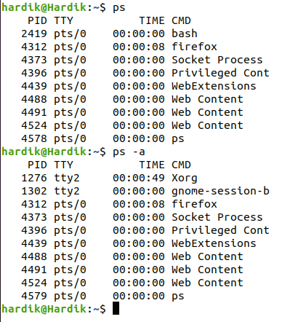
3. Display first 15 and last 15 processes using appropriate command

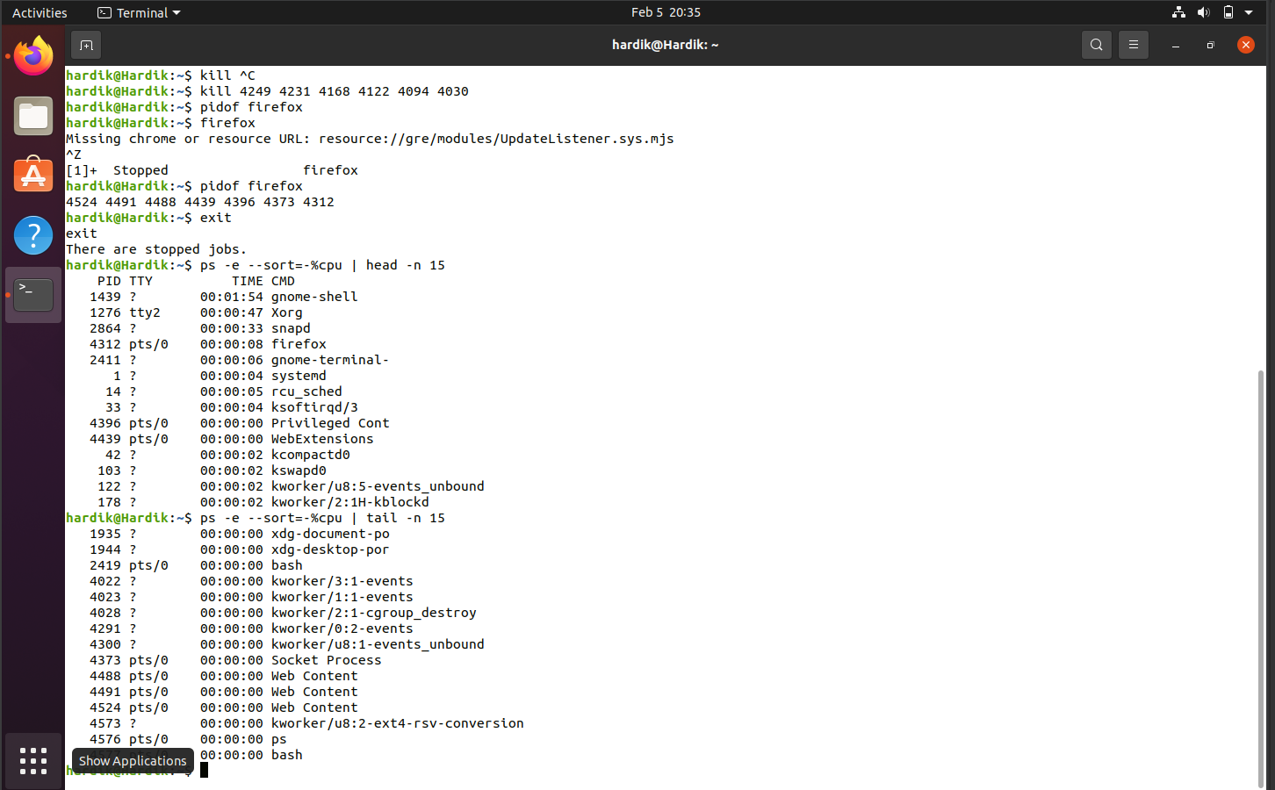

1. Select a process and send it to background

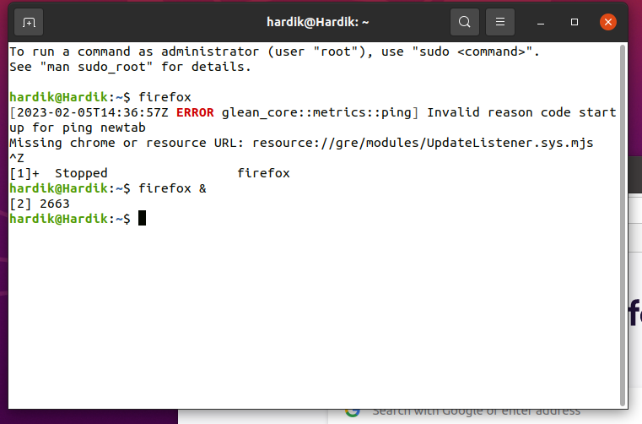

1. Send that process again to foreground

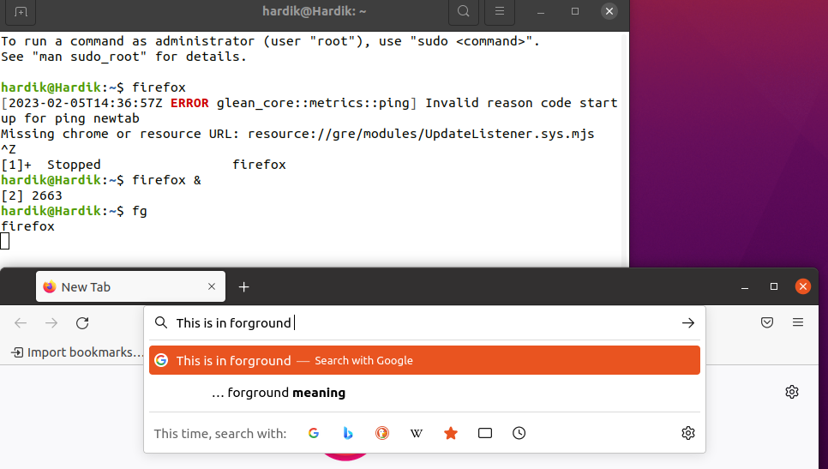

1. Show Zombie and Orphan Processes with the help of an example

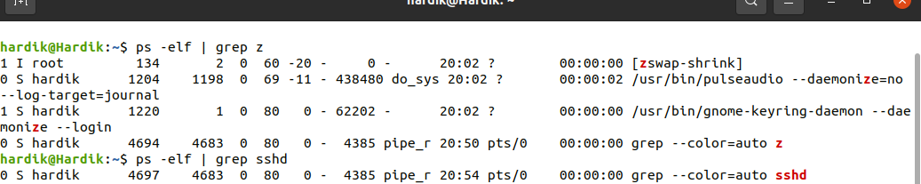

1. Start “firefox” browser on your system. Then kill this process using appropriate command

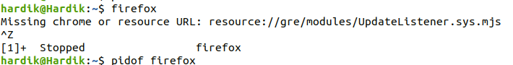

1. Very that “firefox” process is killed

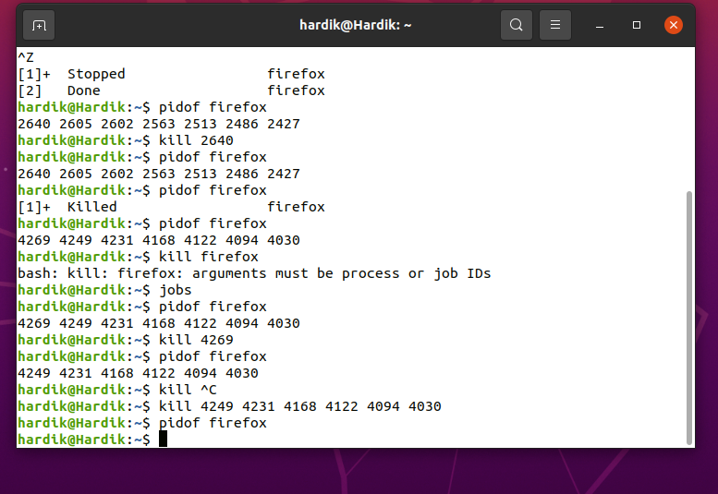

Attach screenshots of output:

1. Managing file permissions.
2. Create a directory of your roll no followed by “ECS” in your home directory. For ex: “8800-ECS”
3. In this directory write a python program and save it as “details.py” to print group no., roll no. and name of all group members. (Just print in table like formant, without taking any input from the user)
4. Create a file named “output”
5. Write appropriate command to run the above code in the file “output”
6. Make this “output” executable
7. Run this “output” file
8. Save the output of the program in another file called as “ourgroup.txt”
9. Display all the permissions of this “ourgroup.txt”
10. Change the permission of the above file such that only the owner can read and write the file. Other users can’t even read or write this file
11. Verify that the above permissions are applied to the file.
12. Give all permissions to all the users on your system to the file “ourgroup.txt”
13. Verify that the above permissions are applied to the file.

**Attach the screenshots**

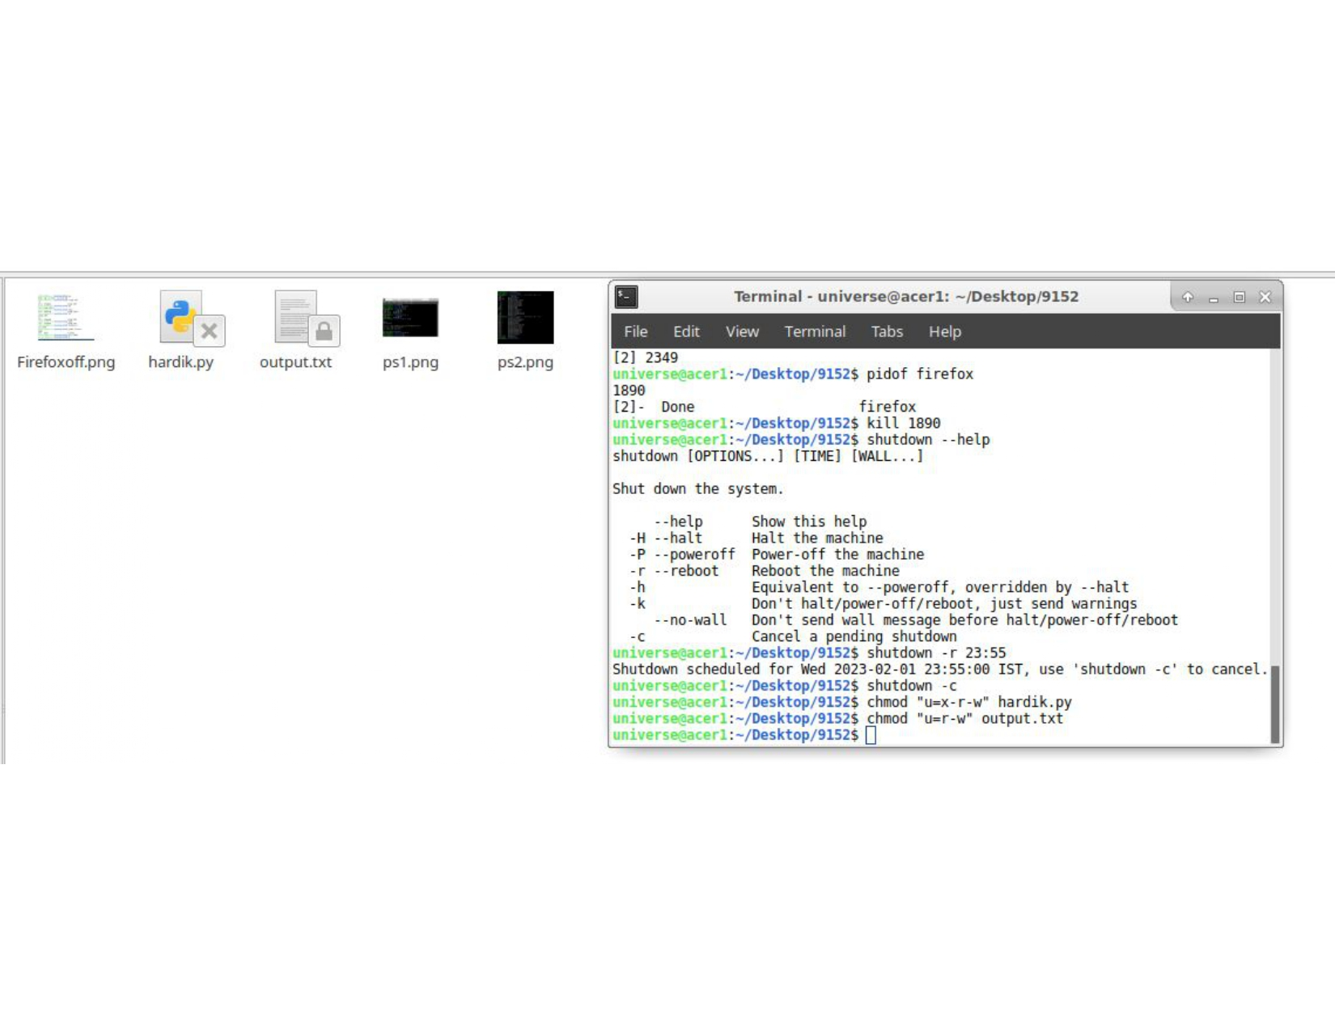

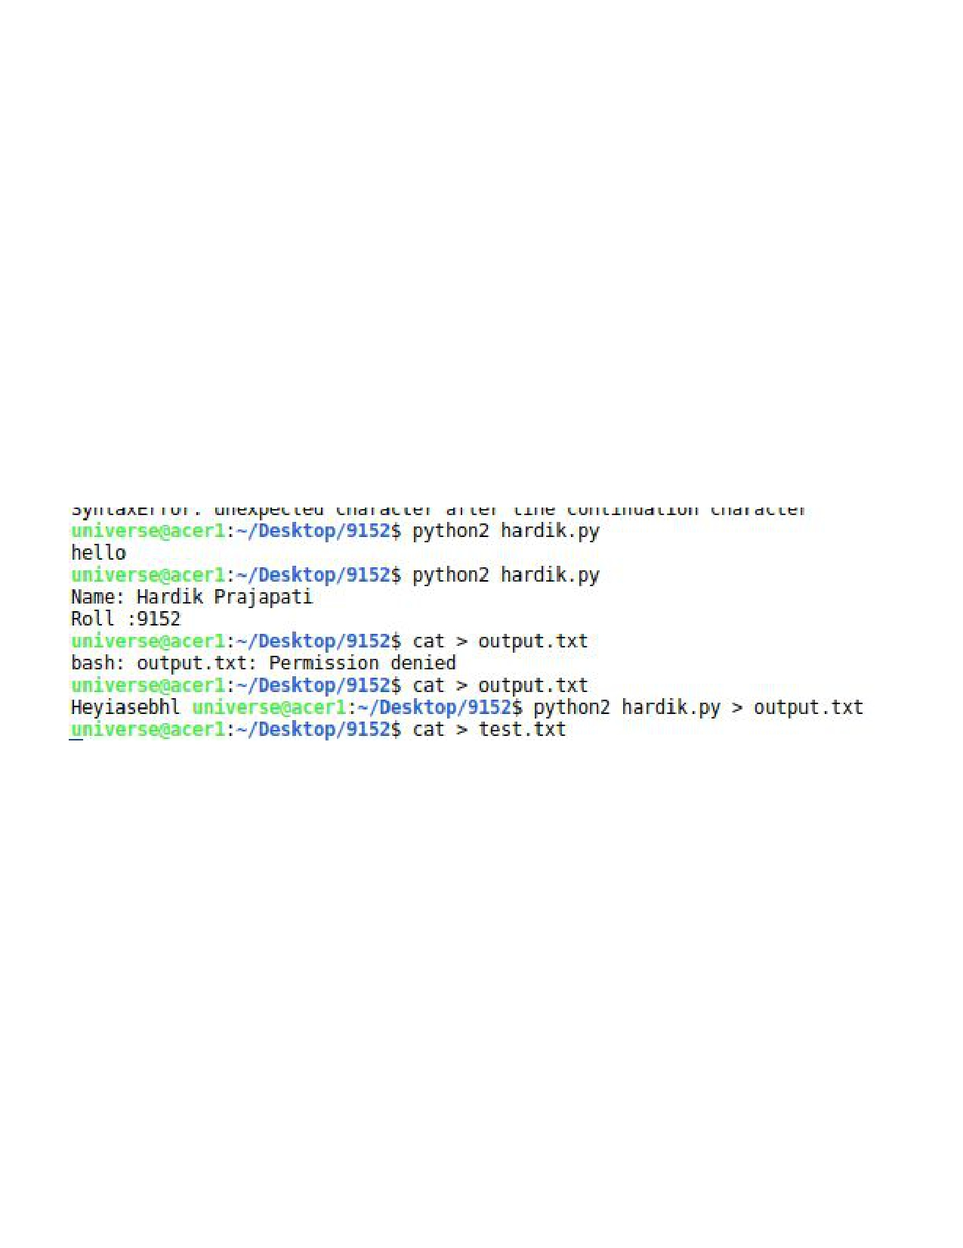

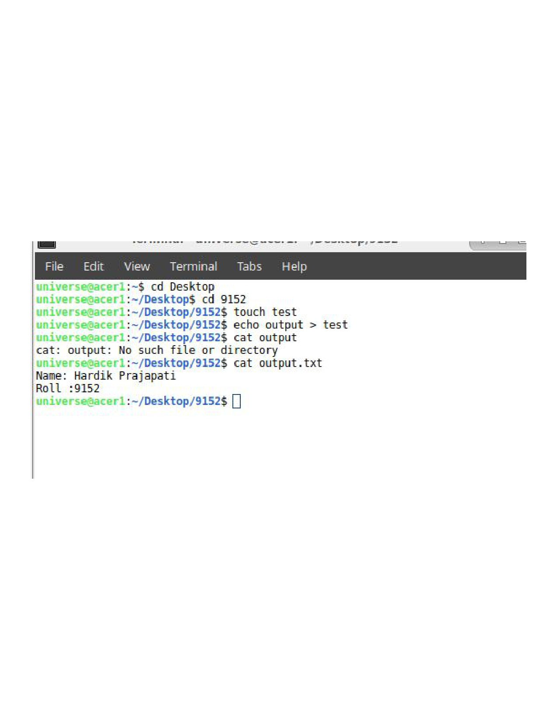

|  |  |
| --- | --- |
| **5.** | **Conclusions & Inferences** |

|  |  |
| --- | --- |
| **6.** | **Post Lab exercise** |

1. Run “top” command on your system’s terminal. Attach the screenshot of it and explain the output

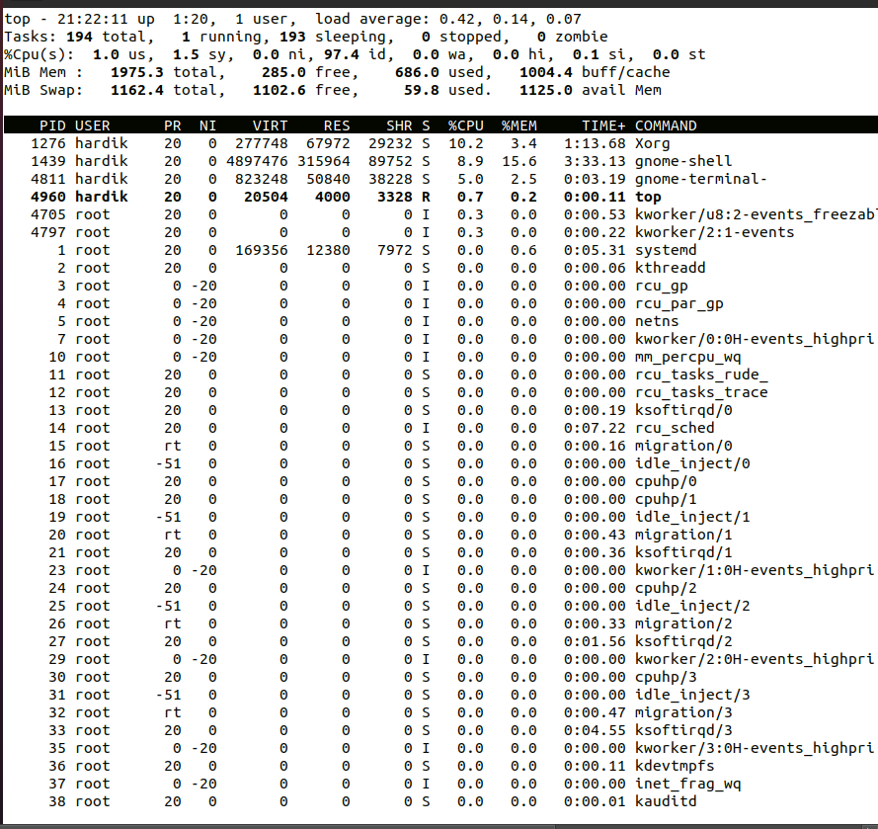

1. Using CRON job, schedule the shutdown of your system at 10 PM today. Verify it. Then cancel the CRON job schedule

